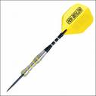
Jubilee Trophy
MATCH DATE / /
301 double start, double finish. Names to be randomly drawn. Each game the best of 3 legs.
Home Team |  |  |  | Away Team
SINGLES
TOTAL WINS |  |  |  | TOTAL WINS
Best Start
Highest Score
Best Game Shot
Least Darts

Home Captains Signature
Away Captains Signature

